E-BOOK STORE
@CREATIVITY THINK (9483175986/7019689991)

ABSTRACT:
The E-Book Store is a web application designed to facilitate the online sale, download, and management of digital books. Users can browse the book catalog, purchase or download e-books, rate and review books, manage wishlists, and access interactive dashboards for tracking their activities. Administrators can manage the book catalog, orders, user reviews, and view analytics through comprehensive dashboards. The backend is implemented using Django and Django Rest Framework for secure handling of transactions and user data, while the frontend utilizes React, Redux, and pdfkit for interactive dashboards, real-time updates, and PDF generation of invoices or receipts..

INTRODUCTION OF THE PROJECT:
The growing demand for digital content and e-books has prompted the development of the E-Book Store platform, allowing users to easily access and purchase e-books online. The system provides features such as browsing, downloading, reviewing, wishlist management, and detailed dashboards. Administrators can manage the book catalog, track orders, moderate reviews, and access analytics for better business decisions. Utilizing Django and Django Rest Framework on the backend and React, Redux, and pdfkit on the frontend, the platform ensures secure transactions, user-friendly interfaces, and effective management for both users and administrators..

PROJECT OBJECTIVES:

• Enable users to browse and search e-books efficiently
• Facilitate purchase and download of e-books
• Allow users to rate, review, and manage wishlists
• Provide dashboards for tracking user activity and purchases
• Allow administrators to manage book catalog, orders, and reviews
• Generate analytics reports for administrators
• Provide secure and seamless transaction management

PROBLEM OF THE STATEMENT:
Traditional bookstores and offline distribution channels limit access to e-books and require manual handling of sales and reviews. Users face difficulties in browsing, purchasing, and managing their digital libraries efficiently. Administrators require a centralized system to manage books, orders, and user interactions effectively. The E-Book Store addresses these challenges by providing a web-based platform for secure e-book distribution, seamless user engagement, transaction management, and analytics dashboards for administrators to monitor activity and business performance..

MOTIVATION OF THE PROJECT:
• Facilitate easy access to e-books for users globally
• Provide a centralized platform for digital book purchases and downloads
• Allow users to track and review books efficiently
• Support administrators in managing catalog, orders, and reviews
• Enable data-driven insights through dashboards and analytics

BLOCK DAIGRAM OF PROJECT:

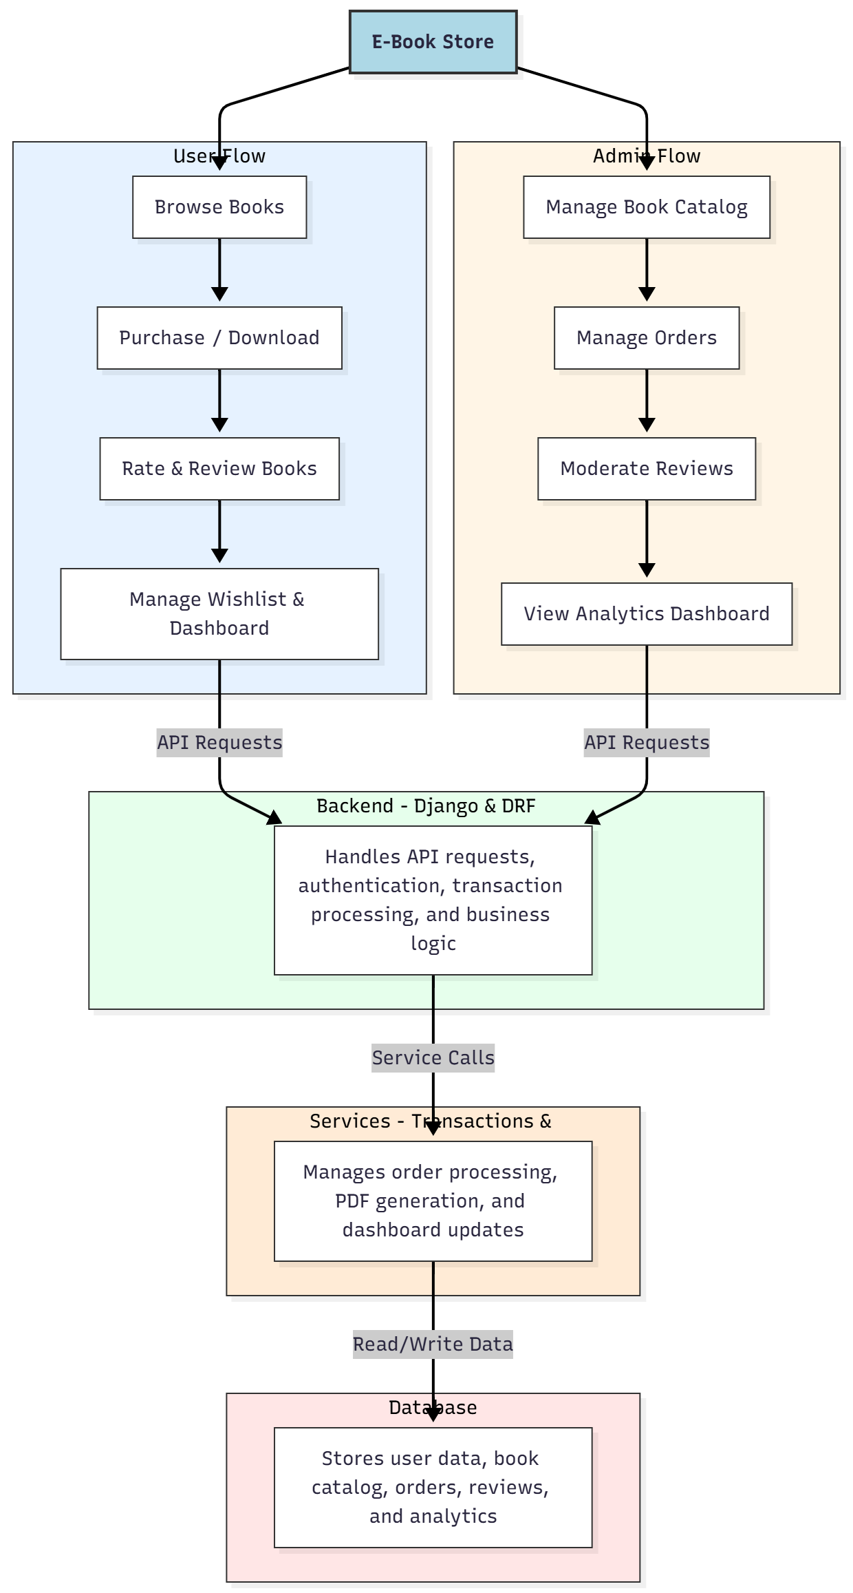

WORKING OF THE PROJECT:
Users browse the e-book catalog, purchase or download selected books, rate and review content, and manage their wishlist with interactive dashboards. The backend handles authentication, transaction processing, and business logic, while services manage PDF invoice generation and dashboard updates. Administrators manage the book catalog, orders, and user reviews, and monitor analytics dashboards to make data-driven decisions. This system ensures a secure, user-friendly, and efficient online e-book platform for both users and administrators..

SOFTWARE REQUIREMENT:
- Backend:
  - Python 3.x
  - Django
  - Django REST Framework
  - SQLite/PostgreSQL
- Frontend:
  - Node.js and npm
  - React.js
  - Axios
- Development Tools:
  - Visual Studio Code
  - Postman (for testing APIs)
  - Git/GitHub (for version control)
- Server/Deployment (Optional):
  - Gunicorn, Nginx, or Heroku/AWS for hosting

ADVANTAGES OF THE PROJECT:

• Seamless online e-book browsing and purchasing
• Downloadable and printable e-books via PDF
• User reviews and rating management
• Wishlist management for user convenience
• Administrative control over catalog, orders, and reviews
• Interactive dashboards for analytics
• Secure transaction management
• Web-based, cross-platform accessibility

APPLICATIONS OF THE PROJECT:
• Online e-book sales platforms
• Educational content distribution
• Digital publishing houses
• Student and library access to e-books
• Authors’ self-publishing management
• Tracking and managing user engagement
• Analytics-driven content strategy
• Integration with online reading or learning platforms

REFERENCES:

- Django REST Framework Documentation — Django Software Foundation. Django Documentation. Available: https://docs.djangoproject.com/
- Django REST Framework. DRF Documentation. Available: https://www.django-rest-framework.org/
- React. React Official Documentation. Available: https://reactjs.org/docs/getting-started.html
- Redux. Redux Documentation. Available: https://redux.js.org/introduction/getting-started
- PostgreSQL Global Development Group. PostgreSQL Documentation. Available: https://www.postgresql.org/docs/
- MySQL. MySQL Reference Manual. Available: https://dev.mysql.com/doc/
- Git. Git Documentation. Available: https://git-scm.com/doc
- Node.js. Node.js Documentation. Available: https://nodejs.org/en/docs/
- Axios. Axios Documentation. Available: https://axios-http.com/docs/intro
- Socket.io Documentation – https://socket.io/docs/

